General education school named after G.Muratbaev

Essay

The theme: “The advantage and disadvantage of the new technology”

Shakpak village, 2025 y.

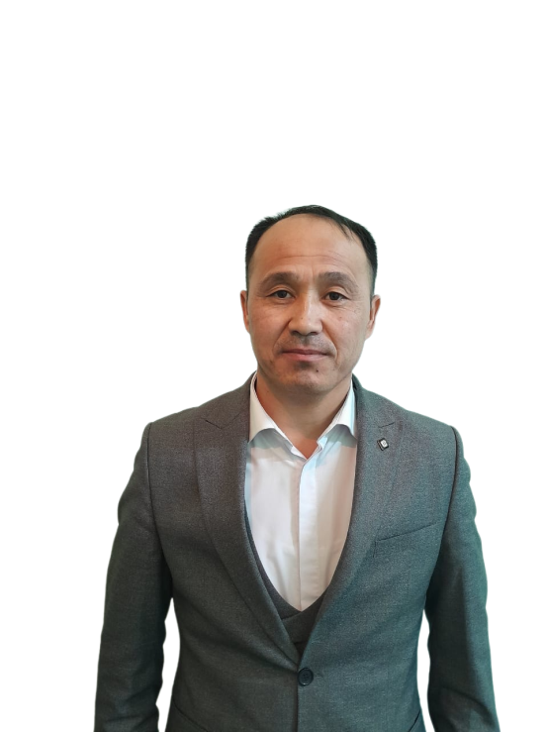Түркістан облысы, Бәйдібек ауданы «Ғ.Мұратбаев атындағы жалпы білім беретін мектептің» ағылшын тілі пәні мұғалімі Әлшеров Ержан Әбдіхалықұлы

The theme: the advantage and disadvantage of the new technology

New technology, the internet, gadgets, computers are one of the very important parts in modern education. Electronic means of communication, due to their simplicity and accessibility, allow schoolchildren and students anywhere on the globe to receive information that was previously inaccessible. From children to adults adapted to the Times. This is due to the fact that today society has no choice but to use new technologies.

[The world continues to move forward by inventing and discovering something new every day, and without these achievements we would not have achieved success in different areas of life. Scientists, researchers, developers and designers from all over the world are trying to embody what makes our life easier and more interesting. Like anything else in the world, new technologies are becoming more useful and harmful. As Times move forward, the age of new technology in invention is renewed. If in the last century it took 30-40 years for a scientific discovery, which was awarded the famous Nobel Prize, to get married, today this time is fast, no more than 4-5 years. Even the most unimaginable things are happening as a component of the invention. We are sure that in a new era in technology, many more types of inventions will be conceived that will catch the eye. We can even say that this is a necessity and trend of the moment.](https://translate.yandex.ru/" \t "_blank)

[Let's see what are the positive aspects that new technologies bring us. First, the computer is one of the very important parts in modern education.Electronic means of communication, due to their simplicity and accessibility, allow schoolchildren and students anywhere on the globe to receive information that was previously inaccessible. The ability to quickly find an answer to the question you are interested in, prepare materials for a report or abstract-all this can now be done through internet without leaving your home. Secondly, thanks to the internet, education may not necessarily be face-to-face, students can study according to the program of their school or institute without leaving home, which can be used if students cannot take classes at school for various reasons. In addition, various online schools and portals that allow you to independently study the material, prepare for exams, improve your knowledge of foreign languages come to the aid of schoolchildren today.](https://translate.yandex.ru/" \t "_blank)

[At the same time, a person does not need to go to many stores in the city and look for the right product. It is enough to find the product of interest on the store's website, find out its address, and then go to the purchase. Finally, if the person interested in buying the item does not have much time to travel, they can order the item that will be delivered home at the chosen time. But like any object, new technologies have the reverse side of the coin. We will consider what are the negative aspects of the use of such technologies for a person. Albert Einstein, the great physicist and mathematician of the twentieth century, left aside the notion: "When technology replaces live communication, we get a generation of idiots." Perhaps this time has come right now, because technology allows you to communicate with a person online.](https://translate.yandex.ru/" \t "_blank)

[On the one hand, it has its advantages, because it is very difficult to find time to meet the current pace of life. However, the vast majority of people actively use this, and it is unlikely to change something in their lives. Some of them prefer to communicate through a real meeting line, even if they have free time. At the same time, talking" online", we cannot see the reaction of the interlocutor — tone, facial expressions, speed of speech, emotionality, and so on. But the worst thing is that people become addicted to phones, computers and other video technologies (including tablets, consoles, etc.). Today, various inventions are being thought out and created every day, which people do not understand if they sleep three. For example, if earlier people used to make eye drops and type as many letters as they could to print paper, now it is possible to make copies or scan them all in electronic form.](https://translate.yandex.ru/" \t "_blank)

[The main harmful factors affecting the body of a computer, smartphone or tablet user include: - a long sitting position; - the effect on the body of electromagnetic radiation emanating from the screen; – eye fatigue and a large load on vision; – overload of the joints of the back, neck, arms; - severe stress when losing information. In conclusion, I would like to note one important criterion that plays an important role in our life: everything is in our hands. If we use IT and other benefits only for useful purposes and in moderation, then life will become easier not only for us, but also for future generations, and they will not suffer from our indifference and laziness. The XXI century is a time of opportunity for us. Therefore, we need to be able to take advantage of the great opportunities that come before us. Only then can we set foot in a bright future and develop!](https://translate.yandex.ru/" \t "_blank)